Tyler Kinsherf  
Module 3: C#   
02/27/2018

I went through a tutorial that showed how to make classes, models, views, view models, partial views, and more. The code for my assignment is included in the ZipFolder.

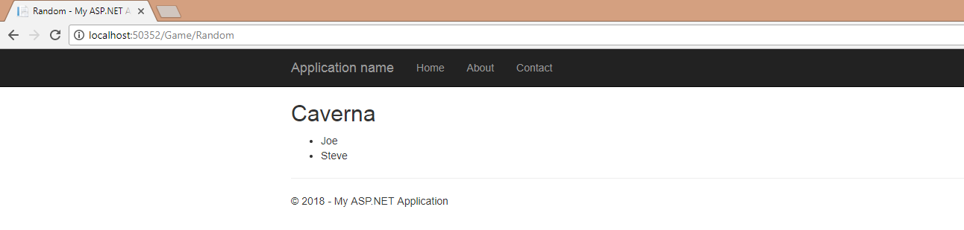

That is the main display of my C# API. I have hard coded A game name and customers who bought the game. The customers exist within foreach loops where I put them in a <ul> by putting the C# in the <li> within the loop.

The _NavBar is a partial view and is called as such @Html.Partial(“_NavBar”)

This app is for looking at a random game and who bought it.